Digital Diplomacy and Nation Branding of Indonesian Ecotourism: An Analysis of the Role of Environmental Education in the YOLO Program on the CubMu Platform as an Instrument of Public Diplomacy
Nur Sabriani Agriana¹, Windy Dermawan², Niksi Riyani Permana³
^{1,2}International Relations Degree, Padjadjaran University, Indonesia, ³TRANSMEDIA, Indonesia
*Corresponding email: nur22009@mail.unpad.ac.id

Article Info |  | Abstract
Article history:  Received Date, month, Year  Publish Date, month, Year |  | This study analyzes the potential of Indonesia’s ecotourism as a soft power instrument in digital public diplomacy through the CubMu platform and the YOLO (You Only Live Once) program. The main objective of this research is to examine how environmental narratives are constructed and disseminated through digital storytelling as part of Indonesia’s efforts to build a sustainable global image. Using a descriptive qualitative approach based on literature review and digital discourse analysis, this study finds that CubMu’s communication practices contribute to framing ecotourism as a reflection of Indonesia’s commitment to global environmental issues, although its dissemination remains predominantly regional. The YOLO program demonstrates potential in reaching the global youth audience through emotionally engaging and visually appealing narratives; however, its effectiveness is limited by risks of over-commercialization and digital infrastructure gaps in rural areas. The study concludes that integrating ecotourism and digital diplomacy can strengthen Indonesia’s position as a proactive actor in environmental diplomacy while opening new avenues for sustainability-oriented soft power.
Keywords:
Ecotourism;
Public Diplomacy;
Soft Power;
Digital Diplomacy;
Indonesia
 |  | This is an open access article under the Lisensi Creative Commons Atribusi-BerbagiSerupa 4.0 Internasional
Corresponding Author:
Nur Sabriani Agriana
International Relations Degree, Padjadjaran University, Indonesia
Email Coresspondent: nur22009@mail.unpad.ac.id

- INTRODUCTION
In the era of globalization and digital transformation, a nation's strength is no longer solely measured by its military and economic capabilities (hard power), but also by its ability to influence global perceptions through values, culture, and an attractive image without coercion. This concept, known as soft power (Nye, 2004), has become a strategic instrument in contemporary diplomacy. Countries with strong and authentic national narratives have an advantage in building more cooperative and sustainable international relations. As cross-border issues such as climate change, sustainability, and digital equality develop, new forms of soft power are emerging through cultural and environmental diplomacy mediated by digital technology.
Indonesia, as a megadiverse nation with over 17,000 islands and over 10% of the world's biodiversity (World Wildlife Fund, 2022), has significant potential to leverage its natural and cultural riches as instruments of public diplomacy. This potential relates not only to tourism promotion but also to building Indonesia's image as a nation responsible for environmental conservation and sustainable development. In this context, ecotourism becomes a strategic channel for articulating sustainability values ​​through cultural experiences and direct interaction with nature. Furthermore, ecotourism has the potential to become a means of soft power when tourism experiences and environmental narratives are capitalized on as representations of national values ​​that support global diplomatic agendas (Fandeli & Mukhlison, 2000).
However, ecotourism-based diplomacy practices face serious challenges. The phenomenon of overtourism, the risk of greenwashing, and the digital infrastructure gap in remote areas can obscure the intended sustainability message. Furthermore, little research has examined how Indonesia's environmental narrative is constructed and disseminated digitally as part of a public diplomacy strategy. Yet, digitalization has disrupted the way diplomacy is conducted, shifting communication authority from state actors to non-state actors such as digital communities, influencers, and online platforms. In this context, digital diplomacy has become a new arena for countries to build their political image through creative and participatory communication strategies.
One concrete example of this shift is CubMu's YOLO (You Only Live Once) initiative, which integrates digital storytelling with Indonesia's ecotourism and sustainability narratives. This platform presents a new approach to public diplomacy, where tourism experiences are packaged as visual and emotional stories capable of reaching a global audience, particularly the digitally active younger generation. However, the effectiveness of this strategy remains to be tested in the context of environmental diplomacy: does this digital narrative truly strengthen Indonesia's image as a nation committed to sustainability, or does it risk being trapped in the commercialization of content?
Against this backdrop, this study aims to analyze how Indonesia's ecotourism diplomacy is implemented through CubMu's YOLO digital platform, and how digitalization can transform the way Indonesia articulates its soft power globally. This study also seeks to fill the gap in the literature regarding the integration of digital diplomacy, ecotourism, and soft power, emphasizing the importance of environmental narratives as a relevant public diplomacy instrument in the era of sustainability. This analysis is expected to foster a deeper understanding of the potential and limitations of ecotourism diplomacy as a means of building Indonesia's global image oriented toward the values ​​of sustainability and ecological responsibility.

- RESEARCH METHODS
This research employs a descriptive qualitative approach with library research as the primary strategy for data collection and analysis. This approach is chosen because it aligns with the characteristics of contemporary international relations studies, which focus on a deep understanding of the construction of meaning, symbols, and diplomatic narratives in a global context. The focus of this research is not on measuring policy impact, but rather on analyzing Indonesia's representation and narrative strategies in articulating ecotourism diplomacy through the CubMu digital platform, specifically the YOLO (You Only Live Once) program. Therefore, this method is considered most appropriate for examining the conceptual and communicative phenomena of soft power and digital diplomacy.
The data used in this study are categorized into two main sources: primary and secondary sources. Primary sources consist of official documents and institutional publications from the Indonesian government relevant to public diplomacy and sustainable ecotourism development, such as reports on the YOLO program by the CubMu platform, policy documents from the Ministry of Tourism and Creative Economy (Kemenparekraf), reports from the Indonesian Ministry of Foreign Affairs (Kemlu RI), and the results of international forums discussing environmental diplomacy and sustainable development. Additionally, digital content such as press releases, online articles, and official social media posts are also included in this category because they represent Indonesia's digital diplomacy communication to a global audience.
Meanwhile, secondary sources consist of academic literature, books, and reputable international journal articles discussing soft power theory (Nye, 2004), public diplomacy (Melissen, 2005), sustainable ecotourism (Fandeli & Mukhlison, 2000), and digital diplomacy, as well as publications from international organizations such as the UNWTO, UNEP, and UNDP, which were used to understand global standards on sustainable tourism and environmental diplomacy. The data collection process was conducted through a systematic search of academic repositories and international journal databases such as Scopus, JSTOR, Taylor & Francis, and Google Scholar, as well as the official websites of government agencies and international organizations. Digital content from CubMu and the YOLO campaign was analyzed as part of the representation of Indonesia's digital diplomacy.
The data analysis method used was qualitative content analysis with a thematic approach through three main stages: open coding to identify conceptual categories such as "sustainability narratives," "digital diplomacy," and "national identity"; axial coding to identify relationships between categories, particularly between digital representations and soft power strategies; and selective coding to construct a theoretical narrative regarding how ecotourism diplomacy is constructed through CubMu and YOLO. This analysis is grounded in the theoretical framework of soft power (Nye, 2004) and digital public diplomacy theory (Bjola & Holmes, 2015), ensuring that the results are not only descriptive but also interpretive.
To ensure the validity and credibility of the findings, this study employed source triangulation by comparing data from official documents, academic publications, and digital content. This approach aims not only to reduce bias but also to strengthen the consistency of the findings through cross-source verification. This triangulation aligns with the principle of epistemological plurality in international relations research, where truth is viewed as the result of a coherent interpretation of multiple narratives and contexts.

- RESULTS AND DISCUSSION
CubMu as a Medium for Digital Ecotourism Diplomacy
As a digital streaming platform developed by Transvision, CubMu, an acronym for “Cuma Buat Kamu,” is a local media innovation that reflects the advancement of Indonesia's digital ecosystem. This platform not only offers conventional entertainment services but also expands its role as a content curation platform focused on education, culture, and the promotion of national potential. Through its various channels, spanning television, film, music, education, and lifestyle, CubMu positions itself as a digital medium capable of combining public entertainment needs with informative and inspirational values. This strategy positions CubMu as a concrete example of the transformation of Indonesian media, which is increasingly adapting to global trends and the dynamics of the digital-based creative industry.
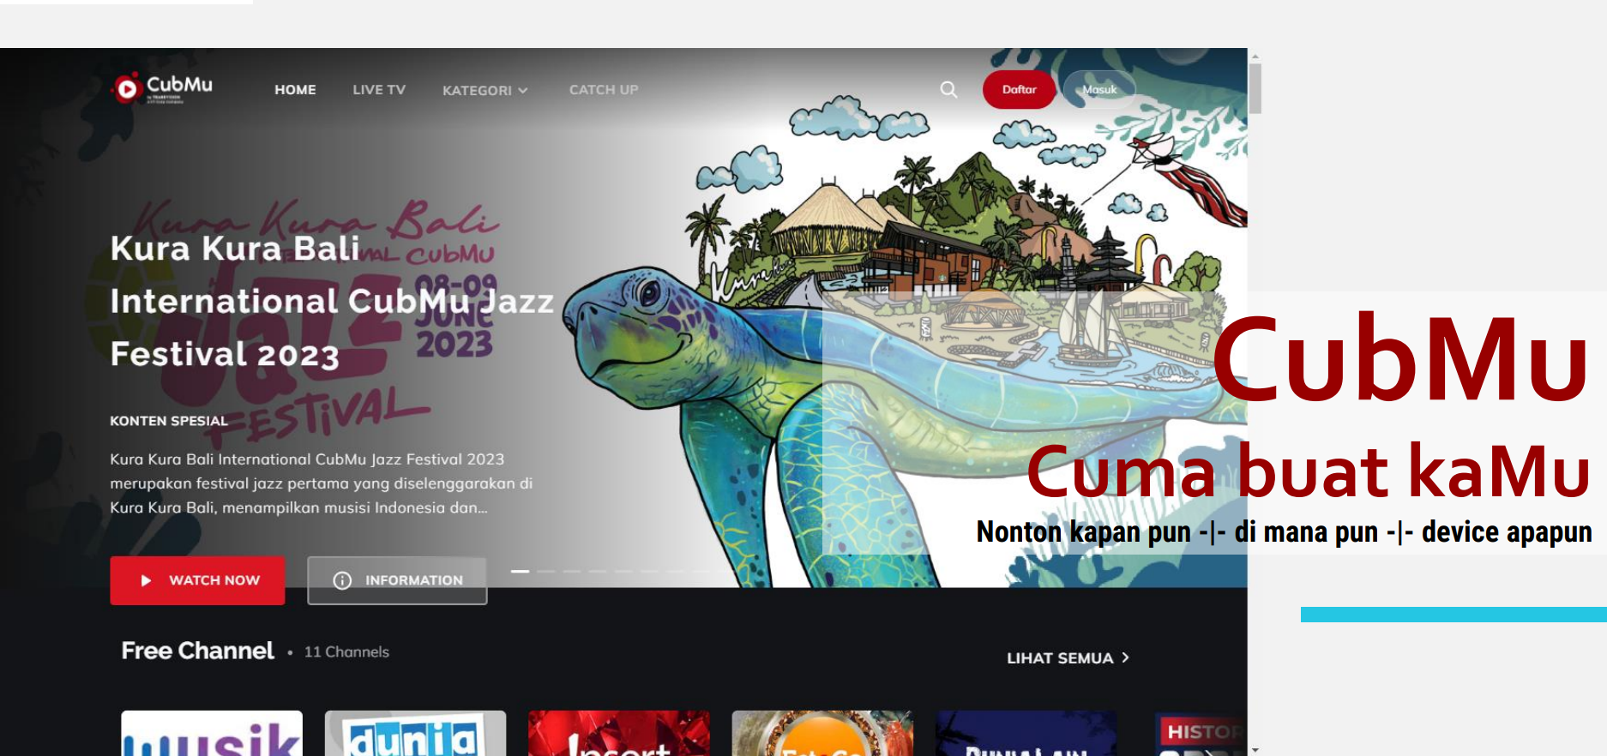

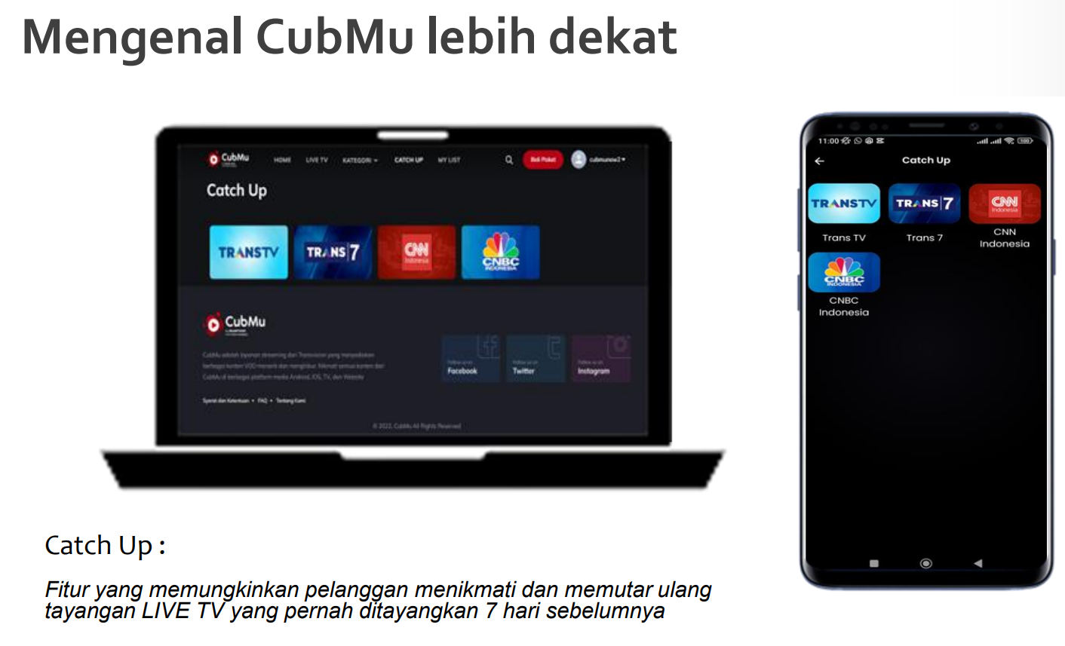
Figure 1. Home Profile (left), Catch Up (right)
Source: CubMu. (2025). CubMu platform. https://www.cubmu.com

One of CubMu's flagship programs is YOLO (You Only Live Once), a travel and adventure show designed to introduce the beauty of Indonesia's tourist destinations to a wider audience. The program explores various attractions, from panoramic sunrises and sunsets, beaches, waterfalls, to the natural beauty of Indonesia's countryside, using a cinematic visual approach and inspiring narratives. Through this program, YOLO not only provides entertainment for viewers but also raises awareness of the importance of environmental conservation and an appreciation for Indonesia's natural diversity. This approach demonstrates how Transvision, through CubMu, strives to integrate the values ​​of ecotourism and ecological responsibility into its digital content.
Furthermore, CubMu, through the YOLO program, functions as a strategic instrument of cultural and environmental diplomacy in the context of modern international relations. By presenting visual narratives about Indonesia's natural beauty and sustainability, the platform contributes to the formation of a positive image of the country (nation branding) in the eyes of the world. This aligns with the paradigm of digital public diplomacy, where media plays a key role in building global perceptions and strengthening Indonesia's position as a sustainable ecotourism destination. By disseminating visual messages emphasizing harmony between humans and nature, CubMu not only expands the reach of cultural diplomacy but also strengthens Indonesia's green diplomacy narrative, a form of diplomacy that places environmental issues, sustainability, and eco-friendly tourism as part of the national soft power strategy.
CubMu expands Indonesia's public diplomacy through three main dimensions: (1) digitizing ecotourism narratives, (2) user participation in the production of meaning, and (3) cross-actor collaboration between the state, the private sector, and local communities. In the first dimension, CubMu leverages the power of digital storytelling, enabling the dissemination of sustainability narratives through high-resolution visuals, emotive cinematography, and narratives that emphasize ecological harmony. This strategy has proven effective in capturing the attention of a young global audience, who are more responsive to visual messages than conventional, declarative diplomacy (Castells, 2011). Narratives such as "Sunset Adventure" or "Hidden Paradise in Flores" not only showcase Indonesia's geographical beauty but also internalize conservation messages, such as the importance of coral reef preservation or community-based waste management.
User participation demonstrates how public diplomacy is transforming into networked diplomacy, where civil society and individuals act as co-creators in building the national image. CubMu provides a platform for user-generated content (UGC), allowing viewers to upload documentation of their travels, provide testimonials, or share conservation activities on social media. This phenomenon creates a diplomatic multiplier effect, where each individual post contributes to the spread of positive Indonesian narratives in the global digital space (Bjola & Holmes, 2015). Thus, CubMu is not simply an entertainment medium but also an arena for participatory diplomacy, enabling users to become non-state actors in disseminating sustainability values.
This cross-actor collaboration demonstrates that CubMu functions as a public-private digital diplomacy platform. The YOLO program involves various stakeholders, such as the Ministry of Tourism and Creative Economy, local communities, and digital influencers with a global following. This collaboration reflects a multi-stakeholder diplomacy model that adapts to the fragmented global communications landscape. By partnering with international public figures and travel influencers, CubMu expands the reach of Indonesian diplomacy beyond official government channels. This strategy is in line with Nye's (2004) idea that in the era of globalization, a country's international appeal and legitimacy depend not only on its foreign policy, but also on public perceptions formed through cultural and media interactions.

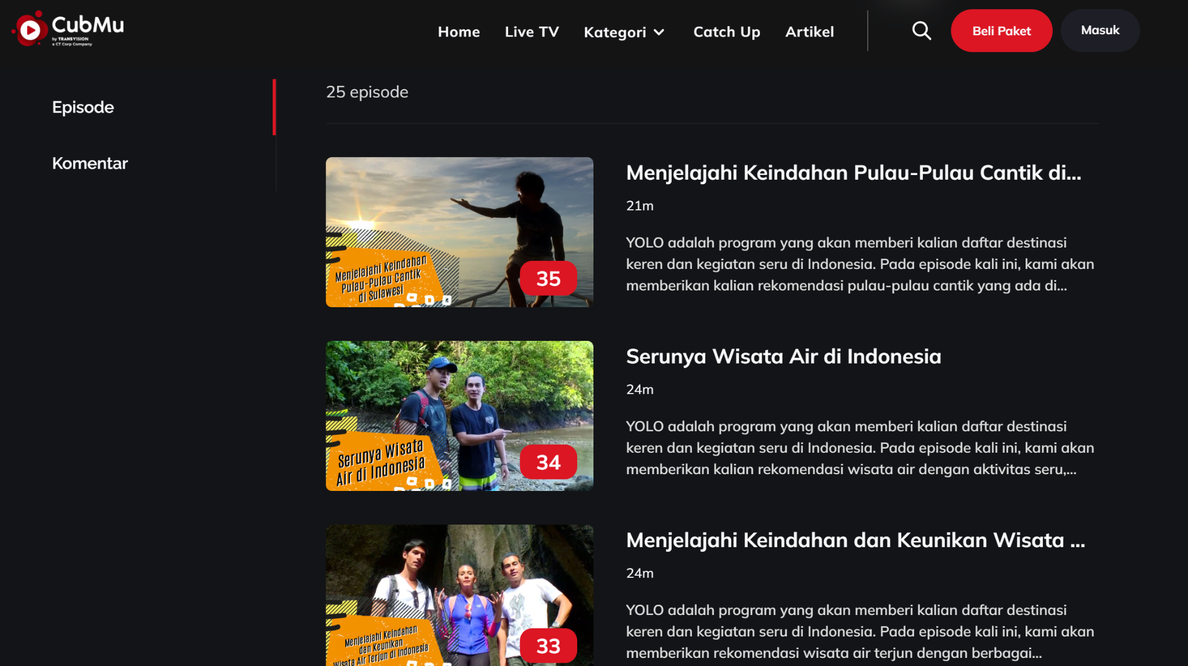
Figure 2. List of YOLO Program Episodes
Source: CubMu. (2025). CubMu platform. https://www.cubmu.com

The YOLO program has become a concrete symbol of Indonesia's efforts to build a narrative of sustainability through digital media. In several episodes, the program features activities such as coral reef restoration (coral transplantation) in Raja Ampat, community-based waste management education in Flores, and mangrove conservation on the coast of Bali. These activities are presented not merely as tourist attractions but as experiential advocacy, demonstrating the synergy between environmental conservation and local economic empowerment. Thus, the tourism experience presented through YOLO is not merely aesthetic but also imbued with ecological meaning and moral values. Viewers not only enjoy the natural panorama but are also encouraged to understand the ethical responsibility behind the sustainability of Indonesia's ecosystem.
Empirically, analysis of YOLO content shows a significant increase in digital engagement, such as increased view counts, comment interactions, and re-shares of content by users on other platforms like Instagram and YouTube. This data indicates that digital diplomacy based on emotional narratives is highly effective in building a positive image of Indonesia among global audiences. These findings reinforce Falkner's (2021) argument that the green soft power of developing countries can emerge from a combination of moral representation and digital media innovation. In this way, Indonesia utilizes CubMu not only as a promotional tool but also as an instrument of moral legitimacy in addressing global issues of climate change and sustainable development.
CubMu's effectiveness in supporting ecotourism diplomacy is inseparable from several structural challenges. First, the gap in digital infrastructure in some tourist destinations leads to an uneven distribution of content participation. Destinations with limited internet access, such as the Seribu Islands or Togean Islands, receive less exposure than destinations with robust digital infrastructure, such as Bali and Labuan Bajo. This creates the risk of representational inequality, where Indonesia's ecotourism image reflects only a small portion of the nation's geographic diversity. Second, the potential for greenwashing arises when sustainability narratives are presented only symbolically without substantive verification on the ground. This situation can erode the credibility of Indonesia's environmental diplomacy in the eyes of the international community. Therefore, the integration of sustainability indicators such as the Global Sustainable Tourism Criteria (GSTC) and data transparency are crucial steps to strengthen the authenticity of digital ecotourism narratives.
Thus, CubMu plays a crucial role as a green soft power instrument that represents a new face of Indonesian diplomacy: adaptive, participatory, and oriented toward sustainability values. The narrative developed through the YOLO program demonstrates that environmental diplomacy need not be conveyed through formal diplomatic statements, but can be realized through visual and emotional experiences that transcend cultural and geographic boundaries. This strategy emphasizes that in the post-digital era, diplomatic power no longer lies in institutions, but rather in a nation's ability to create a narrative that resonates with the global community.

Ecotourism as an Instrument for Digital Diplomacy and Indonesia's Nation Branding through CubMu and the YOLO Program
The birth of CubMu, Transvision's digital streaming platform, marks a new chapter in Indonesia's public communication and digital diplomacy strategy. Unlike conventional entertainment platforms, CubMu integrates commercial and educational dimensions with national and environmental values. One of its flagship programs, YOLO (You Only Live Once), serves as a narrative medium showcasing the beauty of Indonesian tourist destinations while instilling messages of conservation and sustainability. Through a digital storytelling approach, CubMu constructs Indonesia's image not only as a tourist destination but also as a country with a strong commitment to environmental sustainability.
The YOLO program features visual narratives rich with Indonesia's natural beauty, from beaches and waterfalls to hillsides, as well as eco-friendly tourism activities such as mangrove planting, wildlife conservation, and community-based waste management. Indirectly, these visualizations strengthen Indonesia's nation branding in the eyes of a global audience, while emphasizing that tourism and environmental conservation are not contradictory entities, but rather complementary pillars. Within the soft power framework introduced by Nye (2004), this approach positions CubMu as an instrument that strengthens Indonesia's cultural and moral appeal through non-coercive channels.
In line with the digital diplomacy theory proposed by Bjola and Holmes (2015), digital media like CubMu serve as strategic arenas through which state and non-state actors can articulate national values, shape global public opinion, and reinforce a positive national image. In this context, although not a government institution, CubMu has the potential to act as a digital public diplomat, communicating Indonesia's identity in a subtle yet effective manner. The presence of the YOLO program strengthens this role by presenting environmental aspects as a central narrative.
However, herein lies a critical issue: to what extent can CubMu's effectiveness as a public diplomacy tool be empirically measured? The assumption that exposure to environmental content on YOLO automatically enhances Indonesia's positive image among global audiences still requires strong causal evidence. The relationship between digital media reach and the formation of international perceptions is complex, involving intermediary variables such as source credibility, the audience's socio-cultural context, and message consistency across platforms (Chakraborty & Roy, 2022). Thus, CubMu's effectiveness is not solely measured by viewership, but by how the ecotourism message is received, interpreted, and translated into positive attitudes toward Indonesia.
CubMu's influence mechanisms operate in layers. First, through the creation of immersive experiences that foster an emotional connection between viewers and the destinations featured. Narratives accompanied by authentic visuals encourage viewers to build emotional imaginations of a sustainable and environmentally friendly "green Indonesia." Second, through the role of user-generated content (UGC), where users re-upload excerpts or comments about YOLO broadcasts, expanding the narrative's reach and strengthening trust in the message. Research by Gallarza et al. (2021) shows that trust in user-experience-based content significantly influences destination image and visit intentions. Third, CubMu strengthens its diplomatic credibility by collaborating with local figures, environmental activists, and creative workers who act as cultural intermediaries in building the sustainability narrative.
This approach carries the risk of representational bias. The majority of YOLO episodes feature destinations with established infrastructure and popularity on social media, such as Bali or Labuan Bajo, while regions with less digital exposure are marginalized. This imbalance has the potential to create an image that does not fully represent the diversity of Indonesian ecotourism. A discerning critic would point out that CubMu, in this case, still operates within the logic of the entertainment industry, which prioritizes visual aesthetics over equitable national narratives. To maintain the integrity of environmental diplomacy, CubMu needs to ensure a balanced representation between popular destinations and developing regions.
Furthermore, the assumption that every green-themed program automatically reflects a commitment to sustainability can lead to greenwashing if it is not accompanied by independent verification of field practices. Samal (2023) asserts that the credibility of ecotourism narratives can only be established if conservation claims are supported by empirical data, such as carbon emission reduction, biodiversity preservation, and improving the welfare of local communities. In the context of CubMu, this implies the need for transparency regarding local community involvement, economic impacts on the community, and tangible contributions to environmental conservation.
On the other hand, CubMu presents a form of hybrid diplomacy, a combination of state and corporate diplomacy. Through synergy with ministries such as the Ministry of Tourism and Creative Economy and the Ministry of Foreign Affairs, the YOLO narrative has the potential to strengthen Indonesia's position in global environmental diplomacy. Mulyani (2021) emphasized the importance of collaborative governance in ecotourism management, where state and non-state actors complement each other to achieve sustainability goals. Within this framework, CubMu can function as a policy amplifier, a channel that amplifies government policy messages through more popular and emotional visual language.
For this approach to be credible, concrete indicators are needed to demonstrate CubMu's diplomatic contribution. First, from a quantitative perspective, analytical data such as the geographic distribution of viewers, average viewing duration, and content shareability are needed to demonstrate the extent of cross-national influence. Second, from a qualitative perspective, an in-depth content analysis of YOLO episodes is needed to assess the proportion of conservation messages, actor diversity, and the presence of calls to action related to sustainability. Third, a perception survey among international audiences could test the extent to which YOLO broadcasts influence Indonesia's image in terms of environmental and sustainable tourism.
If such empirical evidence can be obtained, CubMu will serve as a concrete example of how digital soft power functions in a developing country context: combining entertainment media, cultural diplomacy, and environmental advocacy within a single national digital ecosystem. This approach also demonstrates how ecotourism can become a vehicle for norm entrepreneurship, the process by which sustainable values ​​are introduced and normalized in global public discourse (Finnemore & Sikkink, 1998). Thus, ecotourism diplomacy through CubMu and the YOLO program not only serves to shape Indonesia's positive image but also expands the space for public participation in public diplomacy. This platform bridges the relationship between the state, local communities, and global audiences in a mutually reinforcing communication chain. However, its effectiveness remains dependent on transparency, narrative validity, and program continuity. Without these, digital diplomacy risks remaining at the performative level of mere image-building without substantial diplomatic impact.

The Strategic Impact of CubMu–YOLO on Environmental Diplomacy and Repositioning Indonesia's Image on the Global Stage
The development of digital soft power through CubMu and the YOLO program demonstrates a new direction in Indonesian public diplomacy practices. In an era where diplomacy is no longer limited to the realm of negotiations between countries, the existence of digital media platforms has become a crucial arena for shaping global perceptions. CubMu, through its visual and narrative approach, expands the scope of diplomacy from institutional to participatory, engaging the public as both subjects and actors in disseminating Indonesian environmental and cultural values.
Strategically, CubMu–YOLO contributes to the repositioning of Indonesia's image in the international diplomatic landscape. For decades, Indonesia's global image has tended to be associated with natural beauty and welcoming people, but has not yet been fully associated with leadership in sustainability issues. Through the narratives of "responsible tourism" and "life is only once to protect," CubMu builds a new dimension to this image, affirming Indonesia as a country not only rich in natural resources but also with ecological awareness and global responsibility. This aligns with the Ministry of Foreign Affairs' efforts to strengthen Indonesia's diplomatic branding as a green and sustainable nation, as outlined in its post-Paris Agreement 2015 environmental diplomacy strategy (Indonesian Ministry of Foreign Affairs, 2021).
Furthermore, the effects of CubMu's diplomacy can be interpreted through three layers of influence. First, the symbolic layer: CubMu visualizes harmony between humans and nature, constructing an idealized image of Indonesia as a green nation. YOLO broadcasts feature local symbols such as traditional dances, traditional houses, and nature conservation rituals, which serve as expressions of cultural diplomacy. Second, the normative layer, where CubMu articulates the values ​​of conservation, equality, and social responsibility as new norms relevant to the global community. Third, the performative layer, transforming viewers into digital eco-ambassadors through online interactions, reposts, or participation in activities initiated by the platform.
This approach aligns with Anne-Marie Slaughter's (2009) theory of network diplomacy, which argues that modern diplomacy no longer operates within a hierarchical structure but rather within an interdependent network connecting states, media, and civil society. In this context, CubMu serves as a network node that brings together domestic and international actors within the framework of environmental diplomacy. The YOLO program is not simply a media product, but a collaborative platform through which sustainability values ​​are negotiated, disseminated, and internalized globally.
From a soft power perspective, CubMu's strength lies in its ability to build emotional appeal. Through the narrative "you only live once," the conservation message is communicated in a light yet compelling manner, inviting audiences to enjoy life without damaging the environment. The resulting emotions of awe, empathy, and responsibility become a more powerful diplomatic force than formal political persuasion. Nye (2021) asserts that authentic cultural and moral appeals are the most enduring form of soft power, as they operate through trust, not coercion.
However, there are several limitations that require academic scrutiny. First, there remains a gap between digital representation and reality on the ground. Most of the locations featured in YOLO have undergone aesthetic curation and editing, which, while enhancing visual appeal, potentially obscures the underlying social and ecological complexities. This poses the risk of aesthetic diplomacy that overemphasizes superficial beauty without addressing the underlying environmental issues. Second, this type of digital diplomacy is potentially elitist, as access to CubMu and the internet remains limited in some regions, resulting in less-than-inclusive participation of local communities in constructing global narratives.
This criticism emphasizes the importance of integrating eco-literacy and community-based storytelling approaches into CubMu content production. By involving local communities as narrators and key actors, CubMu can strengthen the legitimacy of Indonesia's environmental diplomacy. In the long term, this type of collaboration can also support people-to-people diplomacy, where interactions between citizens across borders become an effective means of strengthening mutual understanding and ecological solidarity.
Geopolitically, CubMu–YOLO also provides strategic value for Indonesia's position in global forums. Indonesia, as a megabiodiversity country, has strong diplomatic capital on issues of climate change and environmental conservation. By highlighting the sustainability narrative through national digital media, Indonesia not only strengthens its moral claim as the guardian of tropical ecosystems but also enhances its bargaining position in international negotiations related to climate finance, sustainable tourism, and green technology. This demonstrates that media diplomacy like CubMu can function as a non-traditional diplomatic instrument that expands communication channels beyond formal state institutions.
Furthermore, CubMu's approach demonstrates that diplomacy need not always be associated with formal and bureaucratic state activities. In fact, in the context of today's digital society, the most effective diplomacy is one that integrates values, emotions, and lifestyles. YOLO capitalizes on the trend of digital lifestyle diplomacy where media consumption behavior, tourism, and sustainable lifestyles represent new diplomatic values. This is consistent with Cull's (2019) view that public diplomacy in the digital era must prioritize engagement and narrative empathy over propaganda.
However, this type of diplomacy requires more mature governance. If not regulated by principles of sustainability and accountability, media diplomacy can degenerate into mere commercial projects capitalizing on green issues. Therefore, a collaborative mechanism is needed between the government, media, academics, and civil society to ensure that every CubMu and YOLO content produced aligns with national environmental diplomacy policies and the Sustainable Development Goals (SDGs) agenda.
From a theoretical perspective, the study of CubMu and YOLO enriches the discourse on digital diplomacy and nation branding in Southeast Asia. Most literature still focuses on state-based digital diplomacy, such as the "Malaysia Truly Asia" or "Amazing Thailand" campaigns, while CubMu represents a more hybrid model, born from the private sector but carrying a diplomatic function. This model demonstrates that diplomacy in the postmodern era is decentralized, where the boundaries between state and non-state actors are increasingly blurred. Thus, CubMu can be categorized as a non-state diplomatic actor that plays a role in shaping Indonesia's cultural narratives in the global space.
Furthermore, CubMu and YOLO emphasize the importance of diplomacy based on affective connectivity the ability to build emotional connections across cultures through digital representation. In this context, diplomacy is not merely about negotiating interests, but also about fostering mutual concern and empathy across nations regarding global issues, particularly the environmental crisis. By building ecological empathy through media, Indonesia has the potential to become a norm entrepreneur leading the advocacy of ethical sustainability in the region. However, the sustainability of digital diplomacy requires long-term consistency. CubMu must ensure that the environmental values ​​it promotes extend beyond aesthetics and are implemented in internal company policies, production strategies, and social impacts for local communities. Cross-sector collaboration, including between academics, NGOs, and local governments, is key to ensuring this media diplomacy maintains its ethical substance.

4. CONCLUSION
This research confirms that Indonesian ecotourism has evolved from a mere economic sector into a strategic multidimensional diplomatic instrument, particularly in the context of developing soft power. The use of digital platforms such as CubMu, through its YOLO (You Only Live Once) program, allows Indonesia to project itself not only as a tropical tourist destination but also as a country emphasizing sustainability, ecological responsibility, and authentic cultural identity. Through digital narratives focused on direct and participatory experiences, international tourists are transformed into active agents of environmental diplomacy, playing a role in conservation, ecosystem restoration, and cultural interactions that strengthen Indonesia's image emotionally and humanistically.
The research findings indicate that digital-based ecotourism diplomacy expands Nye's (2004) concept of soft power by emphasizing green diplomacy, where a country's attractiveness is built through measurable sustainability practices, rather than mere symbolism. The YOLO program demonstrates the effectiveness of an experiential diplomacy approach by leveraging international tourists' involvement in conservation activities such as coral reef restoration in Raja Ampat and reforestation in Leuser National Park, creating emotional bridges between participants and local communities. This approach fundamentally differs from conventional diplomacy, which tends to be top-down and transactional, as it emphasizes participation, interactivity, and the creation of collective meaning through direct experience.
However, several assumptions require critical examination. First, the success of ecotourism diplomacy depends heavily on the consistent implementation of sustainability values. The risk of greenwashing remains, particularly if digital promotion is not balanced with transparent and verifiable sustainability indicators, for example through the Global Sustainable Tourism Criteria (GSTC). Second, the phenomenon of overtourism in prime destinations has the potential to undermine the credibility of Indonesian diplomacy if ecosystem capacity and tourist experiences are not managed sustainably. Third, unequal digital access in remote areas can create a representational gap, resulting in digital diplomacy only highlighting technologically advanced destinations. Therefore, the effectiveness of ecotourism diplomacy requires adaptive and collaborative governance that integrates the government, the private sector, local communities, and international partners.
From a theoretical perspective, this research reinforces the relevance of constructivism in international relations, emphasizing that the success of diplomacy is determined not only by material resources, but also by the construction of identities, narratives, and global perceptions through digital communication and immersive experiences. Indonesian ecotourism thus serves as an arena for meaning-making that shapes international public opinion, strengthens moral legitimacy, and supports Indonesia's position as a normative actor on the global stage.
Strategically, Indonesia's future ecotourism diplomacy requires cross-sector integration through the Indonesian Ecotourism Diplomacy Roadmap, which unites ecotourism, environmental diplomacy, and green economy diplomacy, in alignment with the SDGs, the Paris Agreement, and the Convention on Biological Diversity (CBD). The use of cutting-edge technologies such as big data, artificial intelligence, and blockchain can increase policy transparency, effectiveness, and accountability, while multi-actor collaboration ensures the inclusiveness and sustainability of digital diplomacy practices.
Ultimately, Indonesian ecotourism has established itself as a strategic asset for national diplomacy, combining economic, environmental, and cultural dimensions within a unified narrative. With a digital approach, community participation, and a focus on sustainable practices, ecotourism is transforming into an effective green diplomacy channel to strengthen Indonesia's nation branding and expand its influence globally. Continuous evaluation of the impact of ecotourism diplomacy on foreign policy and international perception is an important step to ensure this instrument remains credible, authentic, and sustainable as a representation of Indonesia's commitment to peace, sustainability, and global solidarity.

5. ACKNOWLEDGMENTS
The author declares that this research was conducted independently without any direct or indirect conflicts of interest that could affect the objectivity or results of the research. All findings and analyses presented are purely academic, uninfluenced by personal or institutional interests of any party. This research also received no external funding support from any institution, organization, or sponsor; all research costs were borne entirely by the author as a personal commitment to the development of Indonesian ecotourism science and diplomacy.
The author expresses his deepest appreciation and gratitude to Windy Dermawan, his supervisor, for his invaluable guidance, support, and insights throughout the research process. Her guidance not only strengthened the academic quality of the research but also fostered critical and reflective thinking skills in analyzing every dimension of the research.
The author also expresses his gratitude to Niksi Riyani Permana, his mentor and Program Production Department Head, for her exceptional guidance and direction in helping the author develop a deep understanding of the substance of this research. Her dedication and expertise have made significant contributions to refining the conceptual framework and research methodology.
The author also expresses his appreciation to Caroline Ndoen, his mentor in the Production division, for her support, constructive feedback, and intensive mentoring, which enriched his skills in scientific communication and digital analysis. He also extends his sincere thanks to his fellow interns at Transvision for their collaborative spirit, technical assistance, and invaluable cooperation throughout the research and writing process.
Finally, he expresses his deepest gratitude to all parties who have provided support, both directly and indirectly, in the completion of this research. Without the contributions, motivation, and assistance of these various parties, this research would not have been possible with optimal results.

6. BIBLIOGRAPHY
Anholt, S. (2010). Places: Identity, image and reputation. Palgrave Macmillan.
Nye, J. S. (2004). Soft power: The means to success in world politics. Public Affairs.
Melissen, J. (2005). The new public diplomacy: Soft power in international relations. Palgrave Macmillan.
Buhmann, A., & Ingenhoff, D. (2015). The 4D Model of the country image: An integrative approach from the perspective of communication management. International Communication Gazette, 77(1), 102–124. https://doi.org/10.1177/1748048514556986
Gallarza, M. G., Gil, I., & Sánchez, M. (2021). The influence of tourist destination image on the image of the country. Tourism Management, 31(4), 1–13. https://doi.org/10.1016/j.tourman.2010.06.001
Wang, J., & Zhang, C. (2021). Cultural diplomacy and nation branding through tourism: A case study of Asia-Pacific countries. Journal of International Communication, 27(3), 301–320. https://doi.org/10.1080/13216597.2021.1937284
Pan, S., Gao, M., Kim, H., & Shah, K. (2018). Sustainable tourism development: A review of research and directions for future study. Sustainability, 10(9), 3120. https://doi.org/10.3390/su10093120

Zahra, A., & McGehee, N. G. (2013). Volunteer tourism: A host community capital perspective. Annals of Tourism Research, 42, 22–45. https://doi.org/10.1016/j.annals.2013.01.002
Claro, M-F., Huguet, J. P., & Serrano, M. C. (2023). Tourism as a soft power tool: The role of public diplomacy in Japan's country and destination branding. Journal of Tourism, Sustainability and Well-being, 11(2), 66–80. https://ideas.repec.org/a/ris/jspord/1071.html
Azeez, I. A. (2023). The influence of digital diplomacy on foreign policy. Journal of Tourism and Environmental Policy. Official URL
Gauttam, P. (2024). Education as a soft power resource: A systematic review. Procedia – Social and Behavioral Sciences. https://doi.org/10.1016/S2405-8440(23)10944-3
Letuna, M. A. (2024). Premium tourism branding through digital diplomacy: A case study of the Labuan Bajo Flores Authority. International Seminar on Management & Diplomacy. Official URL
Suryanti, M. S. D. (2023). Indonesia's digital diplomacy as a tool for promoting Raja Ampat ecotourism: soft power in digital diplomacy. International Journal of Indonesian Relations. Official URL
Nawa, A. S., Faizah, I. N., Amelya, L. A. (2025). Indonesia's digital tourism diplomacy: Enhancing the ASEAN digital literacy program. Proirofonic: Journal of International Relations. Official URL
Nitza-Makowska, A. (2025). China as a “green soft power” and the Belt and Road Initiative. Politics & Governance, 13, Article 9106. https://doi.org/10.17645/pag.v13i2.9106
Ministry of Foreign Affairs of the Republic of Indonesia. (2022). Indonesia in the G20: Sustainable tourism and the future of global diplomacy. https://www.kemlu.go.id
Ministry of Tourism and Creative Economy. (2022). Achievements of Indonesian Community-Based Tourism and Ecotourism. https://www.kemenparekraf.go.id
United Nations Development Programme (UNDP). (2021). Sustainable development goals. https://www.undp.org/sustainable-development-goals
United Nations Educational, Scientific and Cultural Organization (UNESCO). (2022). Indonesia's cultural and natural heritage. https://www.unesco.org/en/indonesia
United Nations Environment Programme (UNEP). (2021). World Environment Day: A global perspective on environmental diplomacy. https://www.unep.org
United Nations World Tourism Organization (UNWTO). (2023). Tourism and sustainability: A global framework. https://www.unwto.org

