Branding Religion and Culture: A Multimodal Analysis of Sedaap and Indomie Ramadan Advertisements in 2025

Sutarman¹*, Akbar Adiwinata², Zainudin Abdussamad², Lela Rahmawati⁴
Master of English Literature, Post Graduate Program, Bumigora University
Email : sutarman@universitasbumigora.ac.id ; akbarwinata57@gmail.com ; samadzain12@gmail.com ; lela_rahmawati@universitasbumigora.ac.id

Abstract
This study investigates how religious and cultural values are embedded in Indonesian Ramadan advertisements through Multimodal Discourse Analysis (MDA). The research focuses on the 2025 campaigns of two prominent instant noodle brands, Sedaap and Indomie, which utilize verbal, visual, and auditory elements to construct persuasive narratives. The study aims to examine how Islamic symbols, national identity, and familial values are communicated through these multimodal resources. Using frameworks from Kress, G., & van Leeuwen, (2006) and theories on pious consumerism and cultural discourse, the findings reveal that the advertisements serve not only as promotional tools but also as cultural texts that reflect and shape Muslim identity. Sedaap emphasizes youthful, pop-cultural appeal, while Indomie presents emotional narratives rooted in gratitude and togetherness. The study concludes that commercial branding during Ramadan actively contributes to the construction of religio-cultural ideology in modern Indonesia. These insights offer implications for media literacy, religious communication, and branding ethics.
Keywords: Multimodality; Advertising; Religion; Culture; Consumerism; Indonesia

INTRODUCTION
Ramadan, the holiest month in Islam, is widely celebrated by Muslims through religious rituals, acts of devotion, and communal traditions. In Muslim-majority countries like Indonesia, Ramadan not only holds spiritual importance but also serves as a fertile ground for commercial and cultural expressions. During this period, businesses intensify their marketing efforts by embedding religious and emotional appeals into various forms of media content such as TV commercials, digital campaigns, and social media advertisements (El-Aswad, 2013). Among the most prominent contributors to this trend are instant noodle brands like Indomie and Sedaap, which routinely release Ramadan-themed advertisements to capture market attention during this sacred month (Bateman, 2014).
Over the years, the composition and strategic orientation of Ramadan advertisements in Indonesia have undergone significant transformation. In 2025, a marked shift towards multimodal advertising strategies—integrating verbal, visual, and auditory elements—can be observed in campaigns by both Sedaap and Indomie. These advertisements are no longer merely commercial tools but have become cultural artifacts that reflect and shape collective religious behavior and social values (Adler, S., & Kohn, 2020; Andersson, 2019; Bolognesi, M., & Lievers, 2020). The campaigns employ Islamic symbols, national narratives, and family-centered stories, transforming everyday marketing into expressions of religio-cultural identity (Machin, D., & Mayr, 2012).
Prior studies have explored religious advertising, Islamic branding, and consumer behavior (Sandikci, Ö., & Ger, 2011; Wilson, J. A. J., & Grant, 2013). However, there remains a gap in the literature regarding the multimodal orchestration of these messages in the Indonesian context—particularly how various semiotic resources interact to construct religious and cultural meanings during Ramadan. While some research discusses Islamic consumerism from economic or sociological perspectives (Rudnyckyj, 2009; Slama, 2017), few have critically analyzed how these messages are composed, framed, and communicated visually, linguistically, and aurally in actual advertisements (Alwi, N. R., & Saad, 2021; Heryanto, 2015; Machin, D., & Mayr, 2012) .
This study adopts Multimodal Discourse Analysis (MDA) as the main analytical lens, drawing on the framework of Kress, G., & van Leeuwen, (2006), who emphasize the co-dependence of various semiotic modes in meaning-making (see O’Halloran, 2008). The study also engages with the concept of pious consumerism (Rudnyckyj, 2009) and cultural discourse theory to examine how Islamic values are commodified and ideologically positioned within popular media texts. These perspectives provide a theoretical foundation for investigating how branding practices intersect with religion and national identity in contemporary Indonesia (Eriyanto., 2012; Nurmila, 2020; Sari, N. P., & Sihombing, 2022).
Given Indonesia’s status as the largest Muslim-majority nation, its media landscape offers a rich context to examine how religiosity is branded and communicated. The case of Indomie and Sedaap’s 2025 Ramadan campaigns is particularly illuminating. Both brands have used familiar imagery—iftar gatherings, Islamic expressions, and family dynamics—to build a narrative of inclusivity and spiritual harmony (Graakjær, 2019; Zhang, C., & Xu, 2018). Their advertisements target broad audiences while subtly embedding ideological messages that reflect and reinforce dominant values in Indonesian Muslim society (Pérez-Curiel, 2020).
Therefore, the objective of this study is to analyze how religion and culture are branded in Indonesian Ramadan advertisements through multimodal strategies. By comparing two leading brands—Indomie and Sedaap—this study seeks to uncover the symbolic and ideological work performed by their 2025 Ramadan campaigns, and how such commercial messages contribute to the broader discourse of piety, nationalism, and consumerism (Sidik, 2018; Siregar, A. L., & Butar, 2017; Van Dijk, 1998).

METHODS
This study employs a qualitative research approach, which is suitable for exploring how meanings are constructed through language, images, sound, and gesture in Ramadan advertisements. As Denzin, N. K., & Lincoln (2011) explain, qualitative research allows in-depth interpretation of symbolic and contextual meaning, particularly in cultural and media studies. The research is not intended to test hypotheses or measure numerical data, but to understand the layered construction of meaning embedded in multimodal communication (Izberk-Bilgin, 2012).
The research design applied is descriptive-interpretive, focusing on the analysis of selected media texts. This design is appropriate for unpacking how advertisements function as cultural discourses that blend religiosity, nationalism, and consumerism (Wilson, J. A. J., & Grant, 2013; ). Compared to prior studies that focus solely on textual content or audience perception, this study offers a holistic multimodal interpretation of the advertisement materials (Sandikci, 2018).
The data source consists of two Ramadan-themed video advertisements from 2025: one by Mie Sedaap and the other by Indomie. These videos were purposively selected because they were the official flagship campaigns published on each brand’s verified YouTube channels during Ramadan 2025. The sampling technique used is purposive sampling, in which the researcher deliberately selects data that are relevant and information-rich (Denzin, N. K., & Lincoln, 2011). No human subjects were involved, and all data are publicly accessible, thus meeting ethical research standards.
Data collection involved downloading, transcribing, and observing each advertisement in detail. The transcriptions focused on spoken dialogue, slogans, and sound effects. Visual elements such as gestures, layout, gaze direction, setting, and symbolic imagery were also noted and categorized (Tønnessen, E. S., & Forsgren, 2021).
The data analysis technique is based on Multimodal Discourse Analysis (MDA), as developed by (Kress, G., & van Leeuwen, 2006). This method examines the interplay of linguistic, visual, auditory, and spatial semiotic resources to understand how meaning is constructed (Sandikci, Ö., & Ger, 2011; Van Dijk, 1993). In addition, elements of Critical Discourse Analysis (CDA) are employed to uncover ideological meanings and power dynamics embedded in the ads (Fairclough, 1995). Categories of analysis include religious symbols (e.g., prayer scenes, hijab, Quranic cues), cultural signs (e.g., family gatherings, mudik, local dialects), and branding strategies (e.g., slogans, tone, mood, framing).
The research is contextualized within the broader framework of pious consumerism (Rudnyckyj, 2009; ), acknowledging that religious sentiments and market interests often intersect, especially during sacred months such as Ramadan. This integrated approach allows the study to explore not only what is communicated but also how and why such messages are constructed in specific socio-cultural contexts (Lindridge, A., & Hogg, 2006).

RESULTS
This section presents the findings from the multimodal analysis of two Ramadan advertisements aired in 2025: Mie Sedaap - Bukber Sedaap Changcuters and Indomie - Ambil Nikmatnya Ramadan Bareng Indomie. The results are structured based on three main semiotic modes: visual, gestural, and linguistic, in line with the Multimodal Discourse Analysis (MDA) framework.
1. Visual Mode
Both advertisements utilize visual imagery to convey religious and cultural meaning:
- Mie Sedaap emphasizes cheerfulness and youth culture by featuring the band The Changcuters. Bright yellow color schemes, Ramadan lanterns, and the dominant placement of product packaging visually highlight themes of togetherness and celebration.
- Indomie, in contrast, uses a softer visual palette to depict emotional narratives—such as waking up for sahur, working late during buka puasa, or traveling alone during mudik. Each setting reflects common Ramadan experiences in Indonesia and evokes a warm, relatable atmosphere.
2. Gestural Mode
- In the Mie Sedaap ad, gestures include smiling faces, hand movements toward the camera, and expressive body language that reinforce enthusiasm and enjoyment. These gestures build rapport with younger audiences and support the ad’s playful tone.
- The Indomie ad highlights gestures of contemplation, solitude, and sharing—such as a character giving a bowl of noodles to a friend. These gestures reflect deeper emotional and cultural dimensions of Ramadan, such as empathy, support, and personal reflection.
3. Linguistic Mode
- Mie Sedaap employs informal, urban slang and English phrases (e.g., “love it baby!”, “sorry boy”) alongside expressions like Alhamdulillah and mantap, blending religiosity with pop culture.
- Indomie uses short, context-specific expressions like Hah! Mau sahur…, Udah, nikmatin aja!, and Ini buat buka puasa ya... to represent common interactions during Ramadan. The language is pragmatic, emotionally expressive, and mirrors natural spoken Indonesian.
4. Thematic Findings
- Religious Symbolism: Both ads include religious references, such as beduk sounds, prayer gestures, and the expression Alhamdulillah, situating the ads firmly in the context of Islamic practices.
- Cultural Values: Themes like togetherness (kebersamaan), gratitude (syukur), and mudik appear consistently in both advertisements.
- Brand Positioning: Sedaap emphasizes fun and youth engagement through pop culture, while Indomie positions itself as emotionally reliable and deeply embedded in everyday life.

Table 1. Semitic modes of Mie Sedaap and Indomie
Advertisement | Visual Focus | Gestural Highlights | Linguistic Style | Dominant Theme
Mie Sedaap | Bright colors, lanterns, band members | Expressive smiles, product pointing | Informal, slang, humorous | Togetherness, Youth Culture
Indomie | Warm tones, solo scenes, public settings | Giving, eating, emotive body language | Everyday spoken Indonesian | Reflection, Empathy, Family

DISCUSSION
This section provides an in-depth interpretation of the findings based on the research objective: to explore how religion and culture are branded in Indonesian Ramadan advertisements through multimodal strategies. The analysis of the 2025 Ramadan campaigns from Mie Sedaap and Indomie reveals that these advertisements are not only commercial artifacts but also ideological texts that reflect and shape Muslim identity, cultural values, and emotional sentiments.
Drawing on Multimodal Discourse Analysis (Kress & van Leeuwen, 2006), the interplay of verbal, visual, and gestural elements is central to constructing meaning. Both advertisements utilize distinct strategies—Sedaap through energetic pop culture integration and Indomie through intimate emotional storytelling—to convey values such as togetherness, gratitude, and piety. These multimodal resources are carefully orchestrated to align with audience expectations during Ramadan, especially in a culturally and religiously rich context like Indonesia (Musahadah, Z. S., & Triyono, 2019; Purnama Yanti, N. P. M., Sujaya, I. N., & Umiyati, 2022).
These findings affirm the concept of pious consumerism (Rudnyckyj, 2009), which posits that religious practices increasingly intersect with market activities. The ads do not simply sell noodles; they package moral and emotional narratives that appeal to religious identity and national values. This is consistent with prior studies such as Sandikci and Ger (2011), who argue that Islamic branding is often embedded in broader ideological frameworks that normalize consumerism as part of religious life.
Moreover, the advertisements function as what Fairclough (1995) terms “ideological discourse”—texts that naturalize specific social values under the guise of cultural familiarity (Dania, R., & Rosi Kumala Sari, 2023; Nur Alifah, & Hidayat, 2023; Purnama Yanti, N. P. M., Sujaya, I. N., & Umiyati, 2022). In this case, ideals such as community, familial unity, and inner peace are marketed through the act of consuming a familiar product. This highlights how advertising becomes a vehicle for cultural reproduction, especially during sacred times like Ramadan.
The next subsections discuss the multimodal composition of each advertisement—Mie Sedaap and Indomie—and compare their approaches in conveying religious-cultural narratives. This analysis not only uncovers how each brand leverages semiotic elements, but also how these strategies resonate with larger socio-religious ideologies within contemporary Indonesian society.
Multimodal Discourse Analysis of Iklan Mie Sedaap
The advertisement of Iklan Mie Sedaap - Bukber Sedaap Changcuters, which uploaded on April, 13th 2025 via YouTube’s channel of TPCTV Official Second @tpctvofficialsecond, is part of Mie Sedaap's Ramadan Edition campaign that carries the theme of togetherness and joy that is showed through the video with duration of 30 seconds long. A band from Indonesia, The Changcuters which consist of 5 members, takes a role as Brand Ambassadors and shows a unique concept that combines Ramadan traditions with their popularity in music that is trend among youth.
Beside of displaying a collaboration between Mie Sedaap and the band named The Changcuters in the moment of Ramadan, the video features with 2 variants of Mie Sedaap itself. Mie Sedaap Goreng, known for its crispy and chewy texture, and Mie Sedaap Soto, which has savory and fresh broth. By seeing the products that is advertised in that moment, it can be decided the purpose of this advertisement is to invite viewers to enjoy the moment of Ramadan more deliciously with Indonesian noodle called Mie Sedaap.

Picture 1. Advertisement model of Sedaap
Visual Mode Analysis
The two main Pictures, The Changcuters members Tria Ramadhani (vocalist) and Dipa Nandastyra (bassist), are in the central position with cheerful and enthusiastic facial expressions. Each of them holds a variant of Mie Sedaap in a position facing directly to the camera, placing the product as the main focus right in front of them. The colour of their clothes is almost the same as the colour of the product and the background of the video, which is yellow, creating visual harmony and strengthening the impression of togetherness and Ramadan cheerfulness. The lantern ornaments hanging in the background become a cultural marker that links to the holy month of Ramadan, providing a relevant time context between the visual and theme. In addition, the bright images and lighting as well as the happy expressions of the two characters further reinforce the message that Mie Sedaap is the right choice for Ramadan moment. Moreover, the Mie Sedaap logo and The Changcuters' name such as picture I are displayed with a bold and attractive typography style, strengthening the brand identity and collaboration between The Changcuters as brand ambassadors and the product. This visual strategy used as in picture I can be said to be a way to attract the audience's attention and effectively convey promotional messages about Mie Sedaap products through Ramadan.
Gestural Mode Analysis

Picture II. Tria Shows preferred variants Picture III. Difa Shows his preferred variant
In Picture II and III of Mie Sedaap's advertisements collaborating with The Changcuters, gesture mode plays an important role in reinforcing emotional messages and attracting audience attention. In the image above, the two main characters show expressive and dynamic gestures. Each of them smiles broadly, with their mouths open, signifying enthusiasm, happiness, and high spirits for their preferred Mie Sedaap variant.
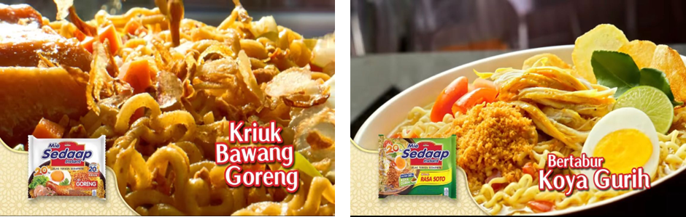
Picture IV. Detail of sedaap Goreng Picture V. Detail of sedaap soto

Continually, they explain in detail why they pick the variant. For example, Tria's choice of Mie Sedaap Goreng has crispy fried onions as shown in Picture IV, and Dipa's choice of Mie Sedaap Soto is soupy with savory koyah as shown in Picture V. By pointing directly at the product with their fingers, Tria and Dipa indirectly direct the audience's gaze at the instant noodles that they promote, while emphasizing that the product is the main focus. Such gestures and expressions create a sense of closeness and engagement, as if they are interacting directly with the audience. These gestures not only support the playful atmosphere built by the two characters in the advertisement, but also establish a strong interpersonal relationship between the characters and the audience, making the promotional message feel more personalized and convincing.
Linguistic Mode Analysis
Mie Sedaap advertisement collaborating with The Changcuters, combines spoken and written language. To analyze them linguistically, here the text which conveyed in the advertisement.
“Bukber sedaap, ala The Changcuters. Wih…udah mau buka nih boy! Ini jagoan gue Mie Sedaap Goreng, love it baby! Ada kriuknya! Hmmm…Sorry boy, kalau gua sih Mie Sedaap Soto. Hangat kuahnya, bertabur koya gurih, emmuaaach. Alhamdulillah…Toppingnya ekstra 20%. Sedapnya dari suapan pertama. Mantap! Terbaik! Ramadan The Changcuters, makin sedaap.”
In the Mie Sedaap advertisement with The Changcuters, the language used is informal, creative, and full of humor, reflecting a modern language style that is casual and close to the younger generation. The spoken sentences are most likely used in everyday conversational style, full of improvisation, with dynamic intonation to keep the audience's attention. In addition, terminology and typical expressions such as wih!, gue, mantap, and terbaik create emotional appeal and closeness to the audience.
There are elements of code switching from Indonesian to English, for example in the phrases of love it baby and sorry boy which reflect the urbanization of language. Those speech are short, fast and dynamic, reflecting a spontaneous and energetic style of speech and representing the persona and attitude of The Changcuters. In addition, the use of descriptive words such as kriuknya, hangat kuahnya, dan tabur koya gurih reinforces sensory suggestiveness, typical of persuasive strategies in food advertising. Overall, this sentence mode combines persuasive, expressive and emotive functions that aim to attract and persuade consumers with easy language.
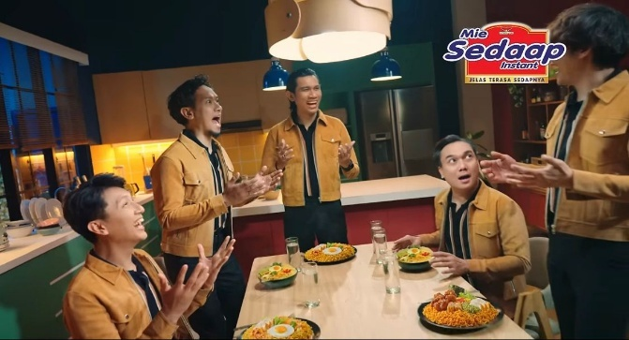
Picture VI. Expresising Alhamdulillah
In picture VI, after hearing the sound of beduk, all members of The Changcuters pronounce Alhamdulillah simultaneously. The expression of Alhamdulillah is not just a religious expression, but also reflects deep cultural values in Indonesian society during Ramadan. Linguistically, Alhamdulillah is a form of praise to Allah that is commonly uttered by Muslims as an expression of gratitude. However, in the context of the advertisement towards Indonesian culture, especially during Ramadan, Alhamdulillah is used as an expression of gratitude and happiness because as Muslims, all members have successfully carried out fasting from dawn to maghrib time and are preparing to break the fast together with Mie Sedaap that have been prepared on the table in front of each of them.
The use of Alhamdulillah also serves as a communication tool that connects religious values with modern lifestyles. By involving The Changcuters, a band known among young people, the advertisement successfully conveys the message that traditional and religious values can harmonize with contemporary life. This reflects that the approach taken by the advertisement is not only to promote the product, but also to promote cultural and religious values that are relevant to its audience who are fasting during Ramadan.
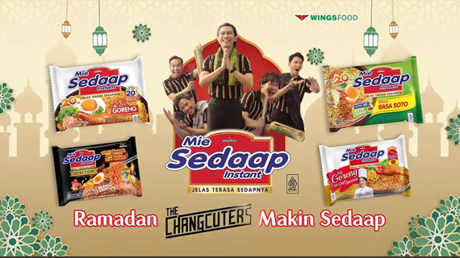
Picture VII. Closing scene of advertisement
The slogan of Ramadan The Changcuters Makin Sedaap in the Mie Sedaap advertising video is a linguistic construction that is rich in meaning and reflects religious and contemporary cultural practices in Indonesia. The slogan is an interesting example of linguistics and popular culture in a religious context. Linguistically, the slogan uses a concise and effective structure, combining three important elements: 1.) time (Ramadan), 2.) pop culture Pictures (The Changcuters), and 3.) taste assessment (makin sedaap).
In terms of religious cultural practices, this slogan represents how Ramadan is not only seen as a month of worship, but also as a social and consumptive moment filled with togetherness and entertainment. So that, this advertisement shapes the reality of Indonesian Muslim society, in which religious practices in Ramadan blend with pop culture and capitalism. Thus, the slogan functions not only as a product promotion tool, but also as a form of cultural narrative that reflects the way people celebrate the holy month of Ramadan in a modern, inclusive and stylish way.
Multimodal Discourse Analysis of Indomie
The advertisement of Iklan Indomie edisi Ramadhan "Ambil Nikmatnya Ramadhan Bareng Indomie” was uploaded on February 25th, 2025 by @ikhsanraditio_official on IR TVC Commercial youtube’s channel. Besides of promoting Indomie as the product, this advertisement shows a positive message about dealing with the various moments that occur during the month of Ramadan that can be both pleasant and unexpected. Through a warm and empathetic narrative, the advertisement illustrates that while we may experience sadness, worry, or confusion during Ramadan, there is always joy to be found in others and in ourselves.
By carrying the campaign Ambil Nikmatnya Ramadhan Bareng Indomie, this advertisement invites its viewers to remain grateful and take lessons from every situation, while showing Indomie's role as a loyal friend who is always present in every moment. This advertisement not only sells products, but also strengthens emotional closeness with its consumers through the values of togetherness, sincerity, and warmth typical of Ramadan.

Visual mode analysis

Picture VIII. Sleeping while waiting for alarm to have sahur Picture IX. Awake for sahur

Several different situations are shown in 30 seconds long of the advertisement. In the first situation, A young man is sleeping in his bed with the dimly lights, and the digital clock shows 3.59 in the early morning. The dim blue light and table lamps create a calm, intimate and personal atmosphere, underlining person’s private moments while sleeping as is shown in Image VIII. Next, Image IX shows the character's shocked expression when he realizes that time is almost up for sahur, adding a strong element of humor and empathy. The young man's facial expression reflects a relatable situation, especially in the month of Ramadan, precisely when it is almost time for sahur.
Through the visuals of picture VIII and picture IX, this advertisement successfully builds an emotional and cultural connection with the audience. The relatable image of waking up for sahur and the surprised facial expressions convey a funny moment in Ramadan even with a little panic.

Picture X. A message to break fasting picture XI. Dijected after cannot join
In the second situation, it conveys a strong emotional and social narrative through visual choices, facial expressions, and background elements. On the first image in Image X, it shows that a young man receives and looks at a message on his phone with message IKUT BERBUKA KAN??? from his friends inviting him to break fasting together. The message with picture shows a group of friends eating together with happy expressions. This visual mode emphasizes the aspect of togetherness and social values ​​in the month of Ramadan, showing that breaking the fast is an important moment to gather.
Meanwhile, the other image in Image XI, the man who saw the message appears to be sitting alone at work, surrounded by a busy and visually cold atmosphere. His facial expression shows dilemma and fatigue, hinting at the conflict between professional obligations and the desire to socialize which suggests he will not be able to attend the event. The contrast of lighting between the warm, colorful image (the bukber photo) and the cold, dim image (the workspace) reinforces the emotional meaning: one presents social warmth, the other shows solitude.

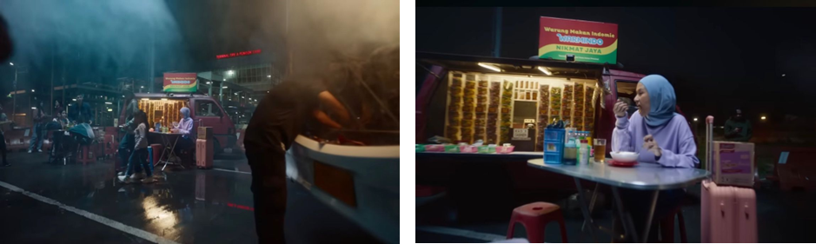
Picture XII. At stall with indomie Picture XIII. Break fasting by eating indomie

In this situation, it can be seen that the main subject (the woman in the light blue hijab) is placed in the center of the frame, making her the center of attention. Then, the background in this scene shows a bus terminal with red digital writing on the building inscribed Terminal Tipe A Pondok Cabe as in Image XII, indicating that the woman is on a journey, possibly far from home or family. In Image XIII, it shows the woman's facial expression as she spoons a bowl of instant noodles and indicates enjoyment, satisfaction, and a contemplative moment that she may be alone, but she doesn't feel lonely.
Through the Image XII and XIII in this situation, it can be seen that the young woman is breaking her fast alone in a simple food stall (Warmindo) at the terminal, with a suitcase and a box of instant noodles beside her. The dark night atmosphere, the warm lighting from the stall, and the presence of a broken vehicle on the right side create an atmosphere of a delayed journey. This visual conveys feelings of isolation, fatigue, but also the warmth brought by simple food like Indomie. The warm color of the stall's interior, contrasting with the night and rain, and the woman's satisfied expression while eating noodles create the meaning that the warmth of Ramadan does not always come from luxury, but it can be from small meaningful moments
Gesture mode analysis
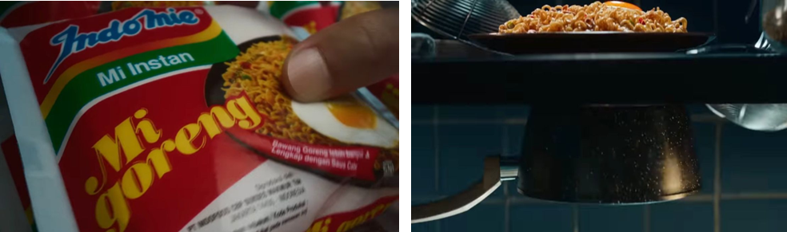
Picture XIV. Taking indomie for menu picture XV. Cooking process
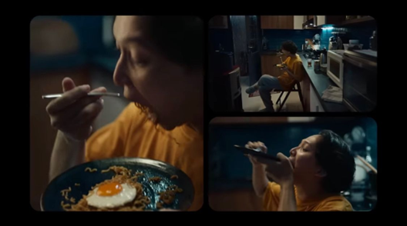
Picture XVI. Enjoying Indomie
In the advertisement of Iklan Indomie edisi Ramadhan "Ambil Nikmatnya Ramadhan Bareng Indomie”, gesture mode is used strategically to convey strong emotional and cultural messages through body expressions, hand movements, and interactions with objects. In the Image XIV, the hand gesture of the young man holding the Indomie Mi Goreng package proves the act of choosing the product in a personal and meaningful way. This movement is not merely functional, but reflects the young man’s emotional attachment as a consumer to the product that has become part of the tradition of breaking the fast. In this context, touching the packaging represents an affectionate decision by choosing the product fast with a pleasure feeling.
In Image XV, two images are seen. There is a plate of noodles served on the table and a frying pan brewing water on the stove. They imply an important transitional moment in Ramadan, showing the act of cooking and the preparation of eating. These show domestic values ​​in preparing one's own food in this case the young man’s food, while strengthening the nuance of readiness to prepare a menu for sahur time.
Furthermore, in Image XVI, expressive body gestures are displayed through the way the young man as main character enjoys the noodles greedily by opening his mouth, closing his face to the plate, and showing satisfied expression. This gesture brings the audience into an intense sensory experience which is the pleasure of food for sahur. The combination of facial expressions, relaxed body positions, and the simple kitchen context create an intimate, authentic, and relatable atmosphere. Without a long dialogue, this gesture communicates that the moment of enjoying Indomie is a form of small, sincere and intimate happiness, which is very closely related to the nuances of Ramadan. Those gestures become the main channel to reveal cultural values, affective experiences, and social meanings that are intended to be conveyed to the audience, especially the young generation who celebrate Ramadan in solitude through simple way such as a quick sahur by eating Indomie.


Picture XVII. Giving indomie picture XVIII. Variant of indomie soto


Picture XIX. Enjoying indomie
This second situation from this advertisement shows that communication in this advertisement is not only through words such as the phrase udah nikmatin aja!, but also supported by gestures, facial expressions, visual backgrounds, and symbolic objects. In the Image XVII, two young men are seen smiling while holding bowls of noodles, it starts that young man’s friend knows that his friend is in a hectic situation of working. He can’t join his group to break the fast and even prepare his menu for breaking fasting for himself. So, the young man’s friend approaches him and offers him Indomie Mie Soto, a bowl of noodles with appetizing toppings as Image XVIII which becomes a visual that triggers appetite and associates Indomie with Mie Soto variant as a pleasure menu for breaking the fast.
By showing an expression of relaxation and mutual understanding, those gestures suggest close friendship and a relaxed atmosphere that is reinforced by eye contact and smiles as shown in Image XIX. This situation shows that even in the midst of the busy professional work environment, the moment of enjoying noodles together still provides space for relaxation and emotional closeness. The combination of visuals, expressions, and food symbols creates a strong visual narrative that Ramadan is also about enjoying simple moments with those who close such as a friend


Picture XX. Enjoying indomie

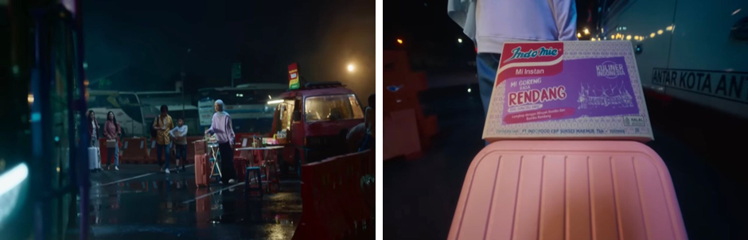
Picture XXI. Going home with indomie
In this situation of advertisement, gesture plays a significant role in conveying a strong nonverbal meaning that is relevant to the Ramadan atmosphere. In the Image XX, the young woman is seen slurping Indomie from a spoon before eating. This gesture culturally represents the care and pleasure of enjoying warm food, while also evoking an authentic and personal impression through her expression. Slurping on food is a small but meaningful act that shows excitement and amusement, especially in the month of Ramadan when the moment of breaking the fast is highly anticipated even though not at home with family.
Furthermore, the Image XXI shows that the gesture of the young woman standing with her body facing the bus and walking towards it conveys the meaning of readiness for a long journey. Her body position and neutral facial expression indicate that she is waiting and redy ready to undertake a long journey in Ramadan which called as mudik. Her left hand appears to be touching or holding part of the suitcase, which signals stability and control, and reinforces the narrative that she is prepared herself to leave the terminal.
In the Image XX, although it does not show full gestures of the young woman, the placement of the Indomie box on top of the suitcase functions as a symbolic gesture. This suggests that Indomie is part of the Ramadan homecoming journey. It means that this product is not only filling her, but also accompanies her in important journey moments of mudik. In this image, gesture mode is not only seen from the movement of the young woman, but also through the position of the product that imply social intent and meaning. The Indomie box is placed prominently on top of the suitcase illustrates that the product is positioned as a souvenir or Ramadan hampers for the family. The placement of this box visually occupies a central position and is in the main line of sight of the camera, as if voicing that Indomie is an inseparable part of the homecoming experience in the moment of mudik Ramadan.
Linguistic mode analysis
Situation I = Hah! Mau sahur…
Situation II = Udah, nikmatin aja!
Situation III = Ini buat buka puasa ya…
Situation IV = Ngapain sih antri! Mending makan di sini
These expressions use informal and everyday language, very typical to Indonesian young generation. They are short, expressive, and direct sentences, reflecting the style of oral communication in a familiar and intimate context. Those expression create an emotional closeness to the audience, especially the younger generation or urban families who are Indomie's target market.
Pragmatically, every expression in every situation has an implied meaning and social function. In sentence Hah! Mau sahur means that an expression of surprise that creates a sense of urgency, also strengthens the time context of sahur in early morning during Ramadan. Udah, nikmatin aja! means phatic (expression of social closeness) and directive, aiming to calm or encourage the recipient of the message to enjoy the moment without stress. Ini buat buka puasa ya shows a social attention and concern for other people's fasting time, reinforcing the value of sharing in Ramadan, and Ngapain sih antri! Mending makan disini is persuasive and comparative sentences. Positioning the product (Indomie) as a quick and enjoyable solution, compared to waiting a long time for food in other places.
In addition, the lexical choice such as sahur, buka puasa, and antri are contextual keywords that are very typical in Ramadan culture. The use of informal words such as udah, mending, and nikmatin reinforce the relaxed and friendly atmosphere. These sentences and word choices strengthen the relationship between every character in the advertisement with the audience. This interpersonal function is important for building a sense of familiarity and equality, where the audience feels that the characters in the advertisement are talking directly to them. The sentences in this advertisement are designed to be short, light, and have a local-cultural nuance, with a focus on the use of informal spoken language that reflects the social reality of Indonesian society during Ramadan. This linguistic mode strengthens Indomie's brand as a product that is familiar and relevant in everyday life.

The Comparative advertisement of Mie Sedaap and Indomie
The Sedaap ad incorporates The Changcuters, a youth-centric pop band, to associate Ramadan with a sense of fun, energy, and modernity. Its visual mode emphasizes color harmony (yellow tones), product centrality, and symbolic elements like lanterns. Gestures—smiling, pointing to the camera—invite identification with the product. Linguistically, the use of expressions like "love it baby", "gue", and "makin sedaap" positions the product as both local and trendy.
The expression Alhamdulillah anchors the ad within Islamic culture, while its humorous tone keeps it appealing to younger audiences. This reflects what Hall (1997) describes as "representation as selective construction," where Islamic values are reframed in contemporary cultural registers.
In contrast, Indomie's ad employs a narrative-driven approach to evoke empathy, reflection, and familial warmth. The ad presents familiar moments—waking up late for sahur, missing a buka gathering, traveling for mudik—and attaches them to the emotional comfort of consuming Indomie. The color schemes (warm light in solitude) and gestures (sharing food, slurping noodles) create a sense of sincerity and realism.
Linguistically, it uses short, context-rich phrases ("udah, nikmatin aja!", "ini buat buka puasa ya") that reflect everyday interactions, creating intimacy with viewers. This is in line with Gee’s (2014) notion of cultural scripts—repeated discourse patterns that normalize behavior and identity. Indomie here becomes a mediator of emotional and religious experience.

While both advertisements succeed in branding themselves as "Ramadan companions," they differ in tone and focus:
Table 2. comparative interpretation of advertisement
Feature | Mie Sedaap | Indomie
Tone | Energetic, Humorous, Youthful | Warm, Reflective, Emotional
Main Strategy | Celebrity & Colorful Imagery | Narrative Realism & Shared Experience
Semiotic Focus | Visual and Gestural Playfulness | Narrative and Symbolic Intimacy
Cultural Framing | Islam x Pop Culture | Islam x Daily Struggle

These findings contribute to the understanding of how multimodal texts shape religious identity and consumer behavior in the digital age. For scholars, the study demonstrates how commercial communication intersects with moral discourse—a hybridization of religion and capitalism. For practitioners, it reveals the power of emotive storytelling and cultural relevance in marketing strategies.
Additionally, the study contributes to media literacy, helping audiences recognize how everyday advertisements serve not only commercial interests, but also participate in the construction of religious and cultural norms.

CONCLUSION
This study examined how religious and cultural values are represented in Ramadan advertisements in Indonesia through a multimodal lens, using two flagship campaigns from Mie Sedaap and Indomie in 2025. The analysis employed Multimodal Discourse Analysis (MDA) to identify how verbal, visual, and gestural elements interact to create persuasive and ideologically resonant messages.
The findings reveal that both advertisements serve not merely as marketing tools but as cultural texts that shape and reflect dominant values in Indonesian Muslim society. Mie Sedaap’s advertisement adopts a youthful and vibrant approach through pop culture integration, while Indomie emphasizes emotional intimacy and everyday experiences during Ramadan. Despite their contrasting tones, both campaigns embed Islamic symbolism, cultural narratives, and national identity, aligning their branding strategies with values of piety, togetherness, and gratitude.
This research contributes to theoretical discussions in the field of multimodal studies, Islamic branding, and critical media analysis. It supports the notion of pious consumerism—where religious sentiment and market logic coexist—and demonstrates how advertising discourse plays a key role in shaping public perceptions of religiosity in the modern Indonesian context.
From a practical standpoint, the study provides insights for media practitioners and marketers on how to design culturally resonant campaigns during religious seasons. It also offers value to educators and policymakers in the field of media literacy and religious communication.
Given the study's limited focus on two advertisements, future research may expand the corpus to include more brands or cross-national comparisons. Studies may also explore audience reception to assess how these multimodal messages are interpreted across diverse social groups.

REFERENCES

Adler, S., & Kohn, A. (2020). A multimodal analysis of a controversial Israeli political campaign ad. Social Semiotics. https://doi.org/https://doi.org/10.1080/10350330.2020.1779459
Alwi, N. R., & Saad, S. (2021). Religious values and consumer purchase intention: A study of halal food ads. International Journal of Islamic Marketing, 2(2), 75–90.
Andersson, H. (2019). Recontextualizing Swedish nationalism in milk marketing: a multimodal analysis. Critical Discourse Studies, 16(5), 583–603. https://doi.org/https://doi.org/10.1080/17405904.2019.1637761
Bateman, J. A. (2014). Text and image: A critical introduction to the visual/verbal divide. In Text and Image: A Critical Introduction to the Visual/Verbal Divide. Routledge. https://doi.org/10.4324/9781315773971
Bolognesi, M., & Lievers, F. S. (2020). How Language and Image Construct Synaesthetic Metaphors in Print Advertising. Visual Communication, 19(4), 431–457. https://doi.org/https://doi.org/10.1177/1470357218782001
Dania, R., & Rosi Kumala Sari, R. K. S. (2023). A Multimodal Discourse Analysis of KFC Fried Chicken’s Video Advertisement. Jurnal Ilmiah Langue and Parole, 6(2), 47–59. https://doi.org/https://doi.org/10.36057/jilp.v6i2.587
Denzin, N. K., & Lincoln, Y. S. (2011). The SAGE Handbook of Qualitative Research. SAGE.
El-Aswad, E. (2013). Images of Muslims in Western and Muslim media. Digest of Middle East Studies, 22(1), 103–121.
Eriyanto. (2012). Analisis wacana: Pengantar analisis teks media. LKiS.
Fairclough, N. (1995). Media Discourse. Edward Arnold.
Graakjær, N. J. (2019). Sounding out i’m lovin’ it: Sonic logos in McDonald’s commercials. Critical Discourse Studies, 16(5), 569–582. https://doi.org/https://doi.org/10.1080/17405904.2019.162418
Heryanto, A. (2015). Identity and pleasure: The politics of Indonesian screen culture. NUS Press.
Izberk-Bilgin, E. (2012). Infidel brands: Unveiling alternative meanings of global brands at the nexus of globalization, consumer culture, and Islamism. Journal of Consumer Research, 39(4), 663–687. https://doi.org/https://doi.org/10.1086/664977
Kress, G., & van Leeuwen, T. (2006). Reading Images: The Grammar of Visual Design (2ed editio). Routledge.
Lindridge, A., & Hogg, M. K. (2006). Spiritual meaning in religious consumption. Journal of Marketing Management, 22(7), 729–755. https://doi.org/https://doi.org/10.1362/026725706778612117
Machin, D., & Mayr, A. (2012). How to do critical discourse analysis: A multimodal introduction. SAGE.
Musahadah, Z. S., & Triyono, S. (2019). Fenomena Hijrah di Indonesia: Konten Persuasif dalam Instagram. Retorika: Jurnal Bahasa, Sastra, Dan Pengajarannya, 12(1).
Nur Alifah, & Hidayat, A. R. (2023). A Multimodal Discourse Analysis of Wardah Cosmetics Advertisement. Jurnal Impresi Indonesia, 3(3). https://doi.org/https://doi.org/10.58344/jii.v3i3.4734
Nurmila, N. (2020). Islam, gender, and visual culture in Indonesia. Journal of Religion and Culture, 30(1), 91–107. https://doi.org/https://doi.org/10.17510/jrc.v30i1.123
O’Halloran, K. L. (2008). Systemic functional-multimodal discourse analysis (SF-MDA): Constructing ideational meaning using language and visual imagery. Visual Communication, 7(4), 443–475. https://doi.org/https://doi.org/10.1177/1470357208096210
Pérez-Curiel, C. (2020). The impact of visual and textual elements in political advertising. Communication & Society, 33(4), 1–16. https://doi.org/https://doi.org/10.15581/003.33.4.1-16
Purnama Yanti, N. P. M., Sujaya, I. N., & Umiyati, M. (2022). Multimodal Semiotics in Cosmetic Advertisement. Retorika: Jurnal Ilmu Bahasa, 8(2), 173–182. https://doi.org/https://doi.org/10.55637/jr.8.2.4866.173-182
Rudnyckyj, D. (2009). Spiritual Economies: Islam and Neoliberalism in Contemporary Indonesia. Cultural Anthropology, 24(1), 104–141.
Sandikci, Ö., & Ger, G. (2011). Islam, Consumption and Marketing: Going beyond the Essentialist Approaches. In J. Schroeder & M. M. Zwick (Eds.). In The Routledge Companion to Visual Organization (pp. 182–195). Routledge.
Sandikci, Ö. (2018). Religion and the marketplace: Constructing the Muslim consumer. Religion Compass, 12(5). https://doi.org/https://doi.org/10.1111/rec3.12255
Sari, N. P., & Sihombing, P. (2022). Multimodal strategies in religious-based advertising during Ramadan. Humaniora, 34(1), 22–35. https://doi.org/https://doi.org/10.22146/jh.v34i1.12345
Sidik, A. (2018). Analisis iklan shampoo Pantene menggunakan teori Semiotika Pierce. Technologia: Jurnal Ilmiah, 9(4). https://doi.org/https://doi.org/10.31602/tji.v9i4.1533
Siregar, A. L., & Butar, M. L. E. F. B. (2017). Critical Discourse Analysis on Wardah halal beauty advertisements. Proceedings AISTEEL.
Slama, M. (2017). Practising Islam through Social Media in Indonesia. 45(132), 39–54.
Tønnessen, E. S., & Forsgren, F. (2021). Multimodal analysis of advertising as culture: Identity, ideology, and affect. Visual Communication, 20(1), 89–107. https://doi.org/https://doi.org/10.1177/1470357220960635
Van Dijk, T. A. (1993). Principles of Critical Discourse Analysis. Discourse & Society, 4(4), 249–283. https://doi.org/https://doi.org/10.1177/0957926593004002006
Van Dijk, T. A. (1998). Ideology: A Multidisciplinary Approach. SAGE.
Wilson, J. A. J., & Grant, J. (2013). Islamic marketing – A challenger to the classical marketing canon? Journal of Islamic Marketing, 4(1), 7–21. https://doi.org/https://doi.org/10.1108/17590831311306327
Zhang, C., & Xu, C. (2018). rgument by Multimodal Metaphor in TV Commercials: A Case Study. Argumentation, 32(4), 501–517. https://doi.org/https://doi.org/10.1007/s10503-018-9455‑w

